RMP Status and Trends  2011 Target Sediment Stations  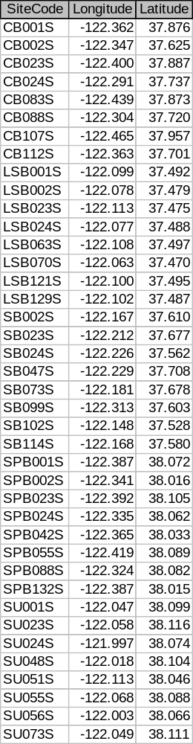 | 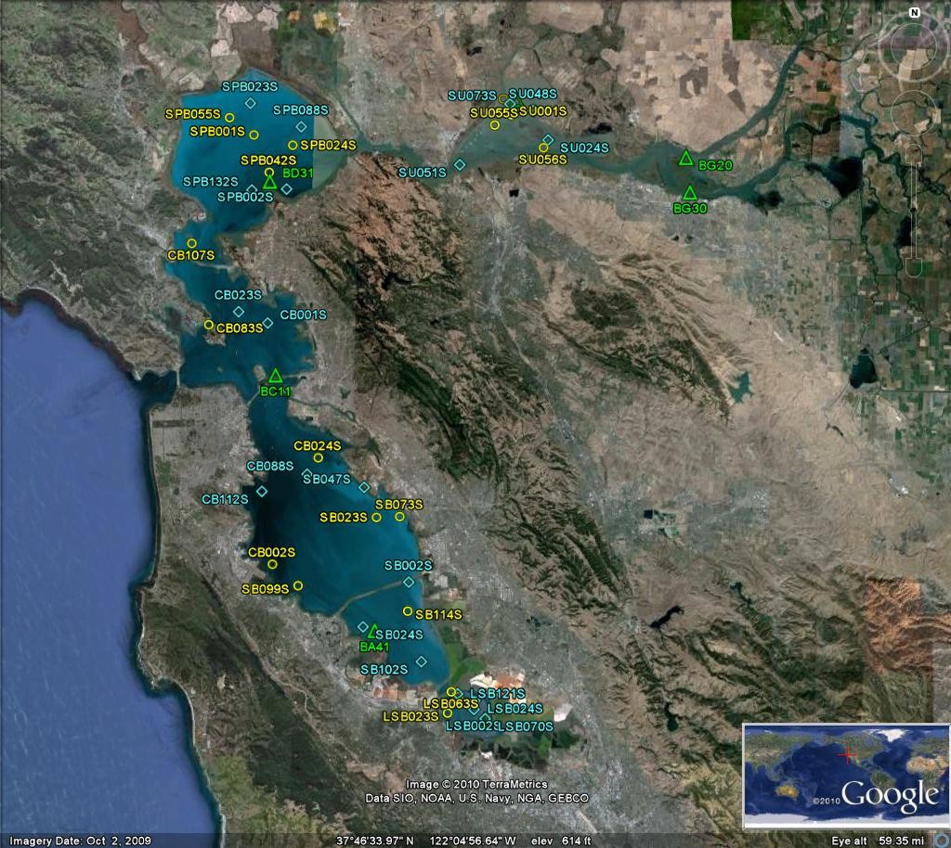

RMP Status and Trends  2012 Target Sediment Stations |  | 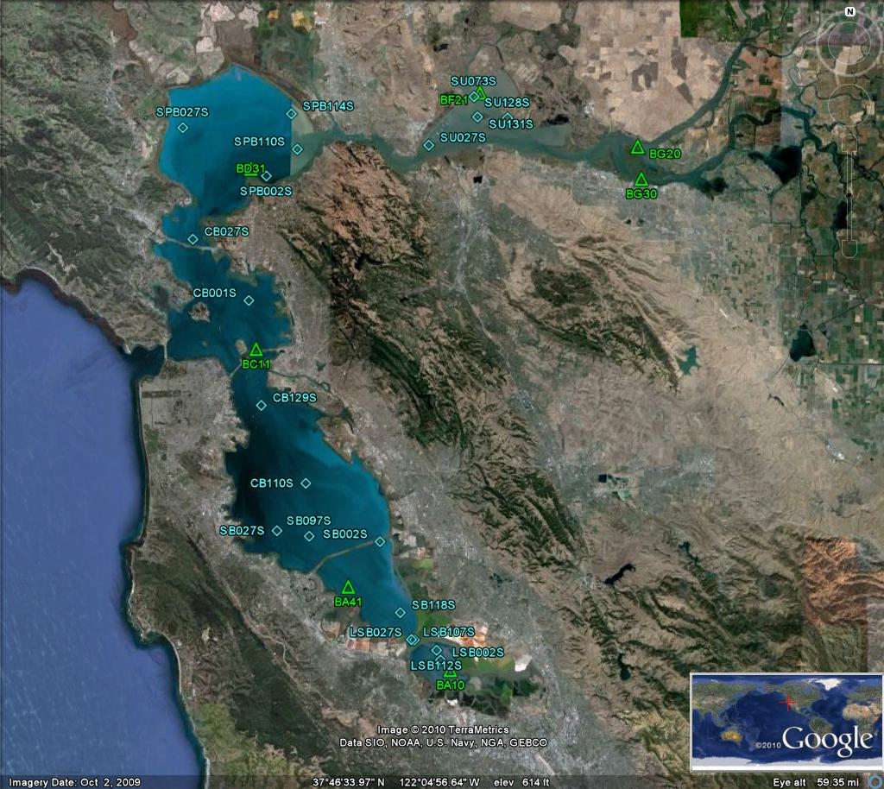
  SiteCode | Longitude | Latitude
  CB001S | -122.362 | 37.876
  CB027S | -122.443 | 37.943
  CB110S | -122.274 | 37.673
  CB129S | -122.340 | 37.759
  LSB002S | -122.078 | 37.479
  LSB027S | -122.116 | 37.501
  LSB107S | -122.120 | 37.501
  LSB112S | -122.084 | 37.490
  SB002S | -122.167 | 37.610
  SB027S | -122.313 | 37.620
  SB097S | -122.267 | 37.614
  SB118S | -122.136 | 37.531
  SPB002S | -122.341 | 38.016
  SPB027S | -122.462 | 38.068
  SPB110S | -122.298 | 38.047
  SPB114S | -122.308 | 38.087
  SU027S | -122.111 | 38.055
  SU073S | -122.049 | 38.111
  SU128S | -122.000 | 38.088
  SU131S | -122.043 | 38.088
RMP Status and Trends  2014 Target Sediment Stations  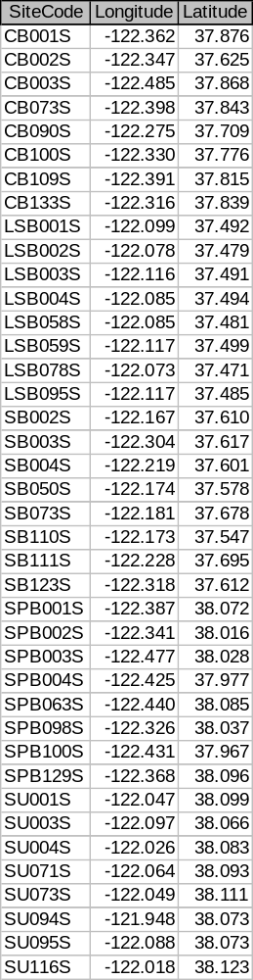 |  | 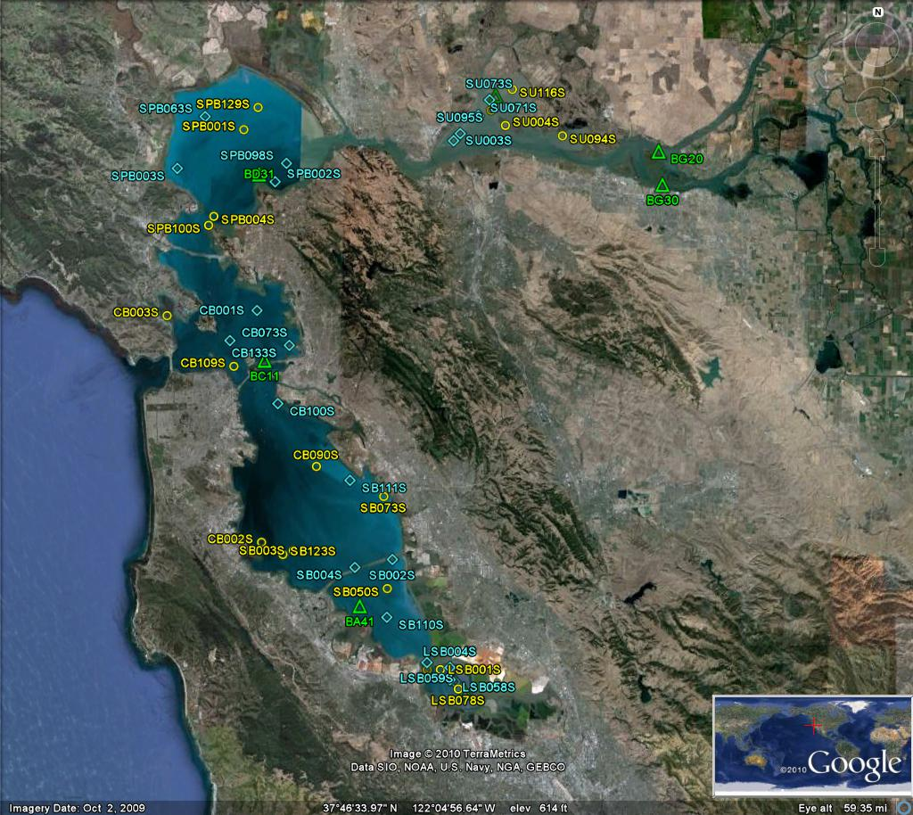
RMP Status and Trends  2016 Target Sediment Stations  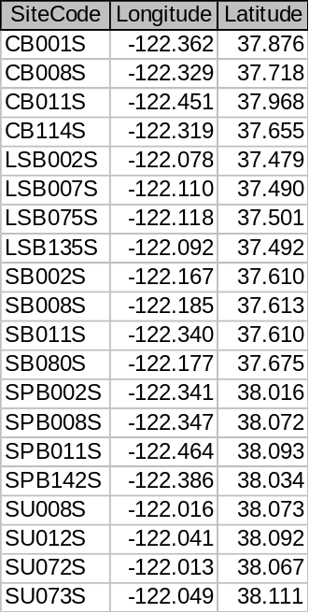 | 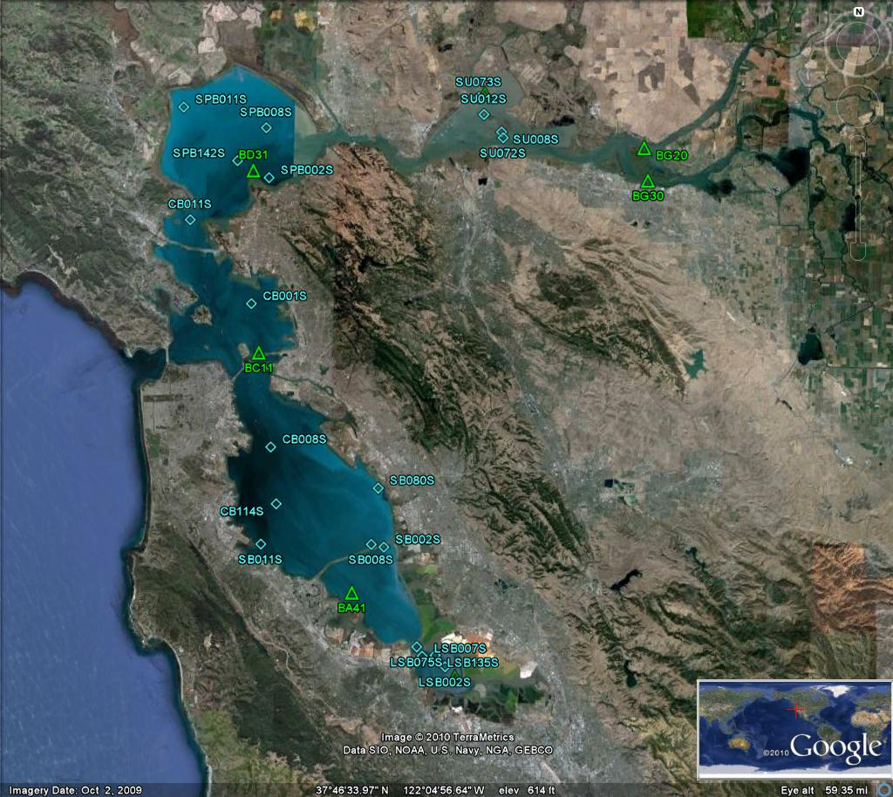

RMP Status and Trends  2018 Target Sediment Stations  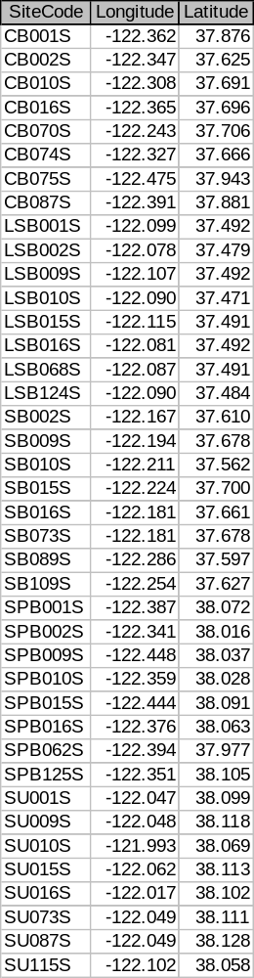 | 

